**Experiment :7 SAIRA BANU M**

**230701278**

**UI Design with GIMP – Aesthetic Collections (Backpack App)**

**Aim:**

To experiment with different app layouts and color schemes using GIMP and evaluate user feedback on aesthetics and usability.

**Output Screenshot**:

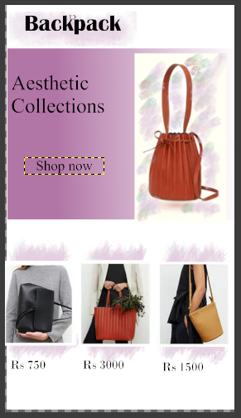

# Procedure Followed:

## Step 1: Install GIMP

I installed GIMP from the official website (https://www.gimp.org) to begin designing the UI.

## Step 2: Create a New Project

Opened GIMP and created a new canvas with dimensions suitable for a mobile app (1080x1920 pixels).  
- This canvas served as the base for my UI layout design.

## Step 3: Design the Base Layout

* Used the Rectangle Select Tool to define sections: header, image area, product display area, and pricing section.
* Filled each section using the Bucket Fill Tool with pastel and aesthetic colors to create a soothing, stylish look.
* Added text elements like 'Backpack', 'Aesthetic Collections', 'Shop Now' using the Text Tool.
* Added interactive elements like the button using shape tools.
* Organized components into multiple layers for better editing and labeling (e.g., Text Layer, Image Layer, Button Layer).

## Step 4: Experiment with Color Schemes

* Created duplicate versions of the layout to try different color tones for the background and elements.
* Used the Colorize Tool and Bucket Fill Tool to test variations in visual presentation.

## Step 5: Collect User Feedback

* Shared the final UI designs with users using screenshots.
* Created a Google Form to collect user feedback about:  
   * Aesthetics of the layout  
   * Usability  
   * Color preferences
* Collected insights to determine the preferred design.

[Screenshots of Feedback :]

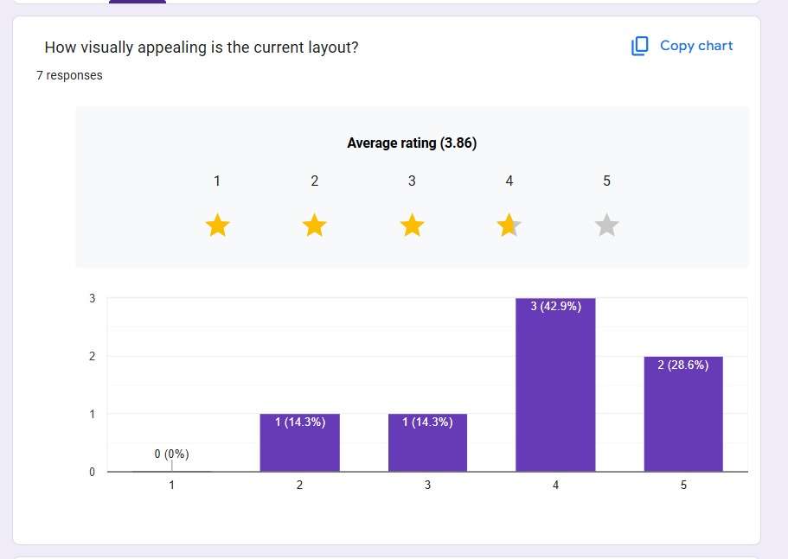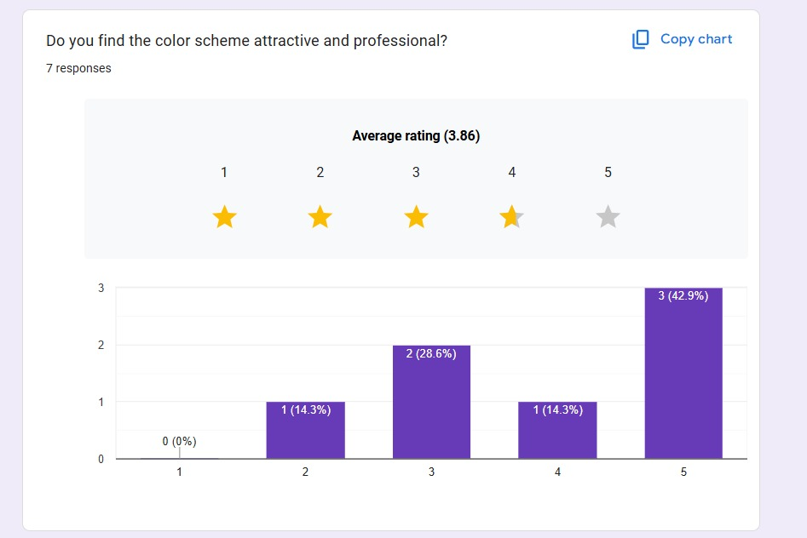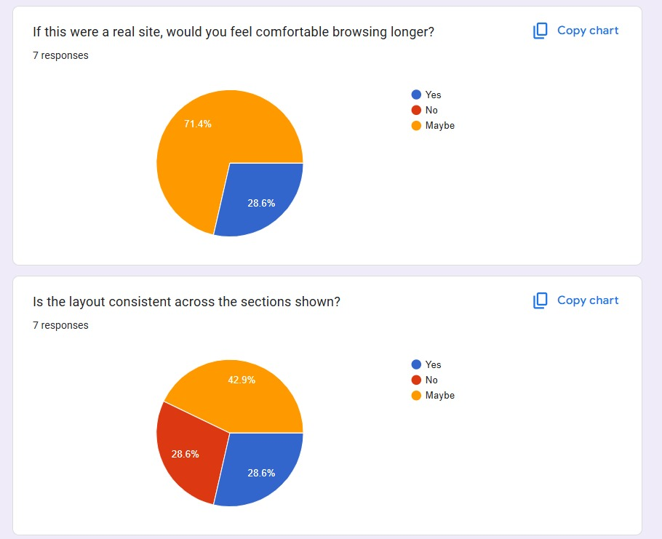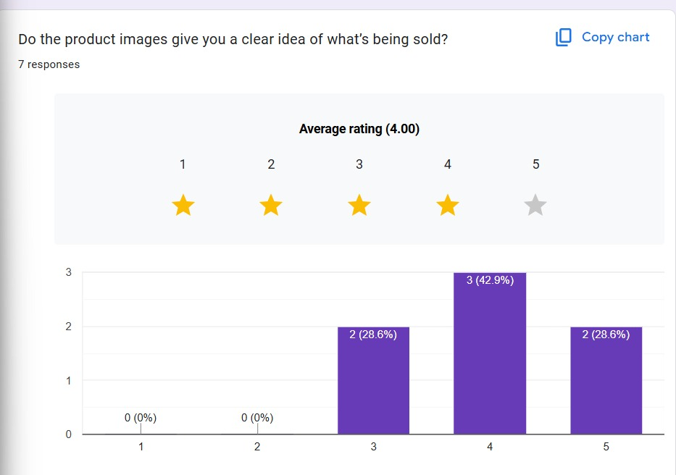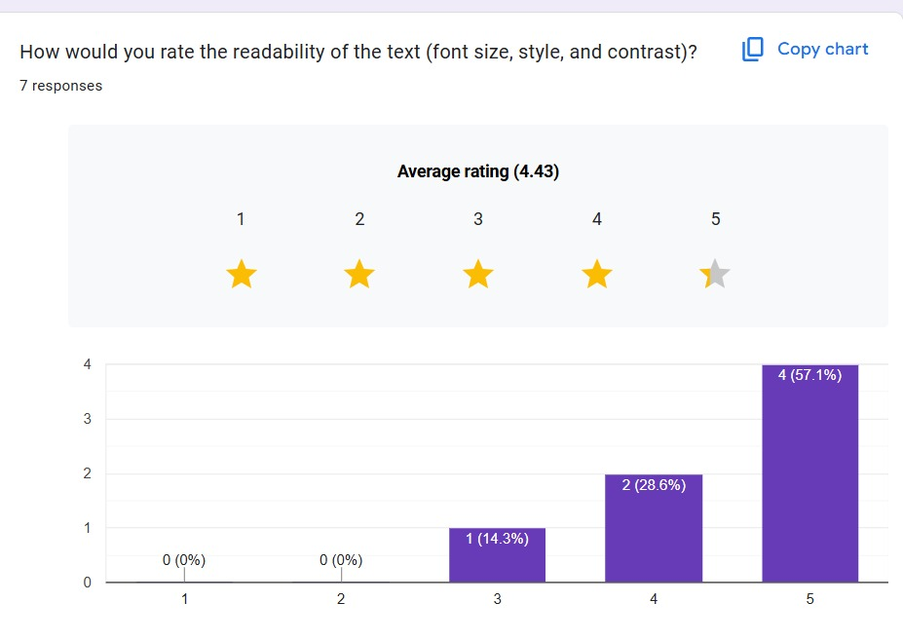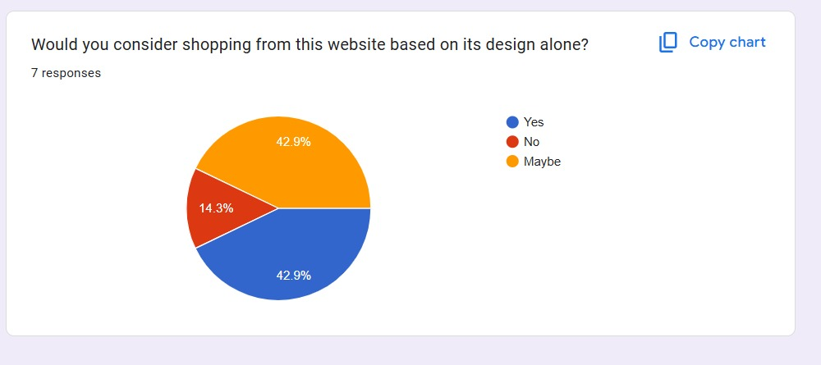

## Step 6: Iterate and Refine

Based on the feedback received, refined the design by enhancing contrast and improving the text visibility on colored backgrounds.  
- Ensured the final layout was visually appealing and aligned with user preferences.

# Final Output:

A clean and modern UI layout for a “Backpack” product page featuring an aesthetic theme with stylish fonts, appealing color combinations, and a minimal product display for an e-commerce interface.